**Output Report with Screenshots**

**1. Minikube Dashboard**

📷 *Input/Output* 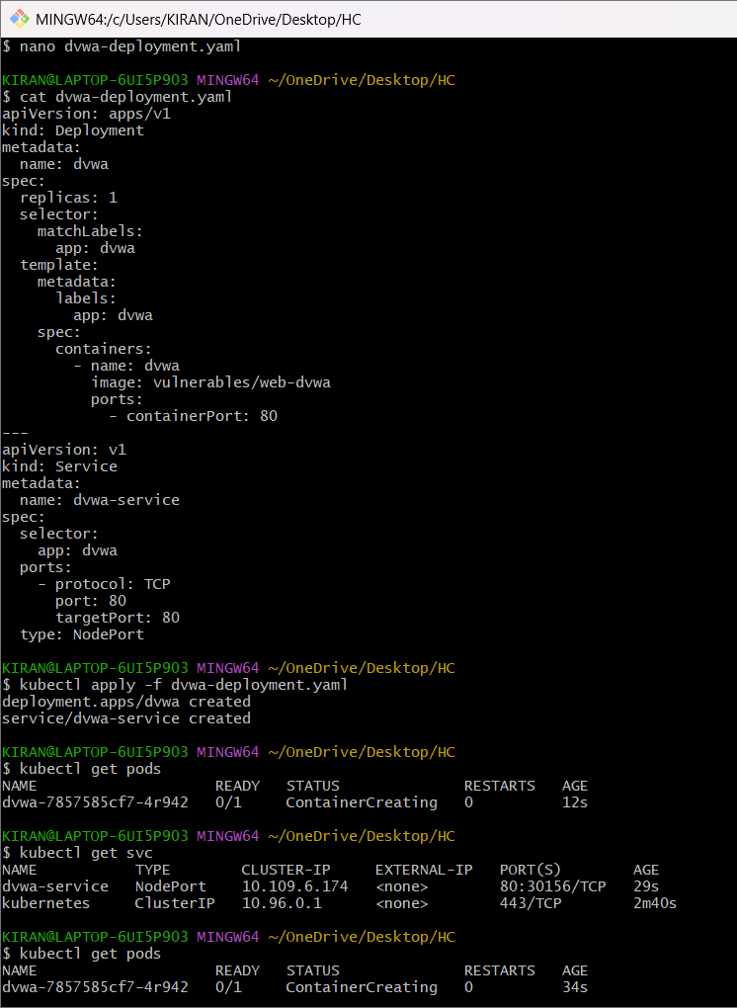

**2. DVWA Deployment (kubectl get pods)**

📷 *Input/Output* 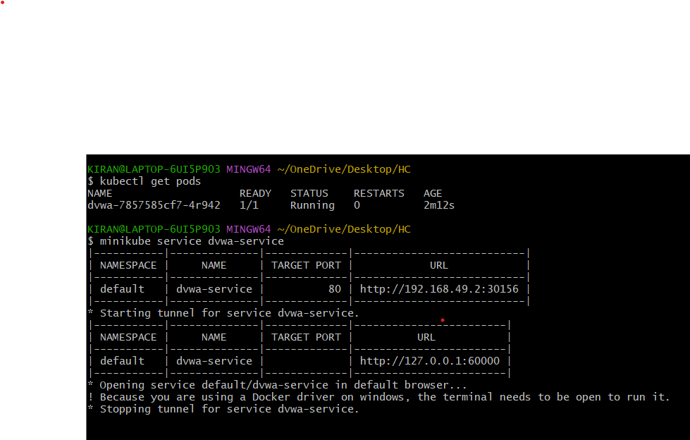

**3. Attack Demonstrations**

**a. SQL Injection**

📷 *Input/Output* 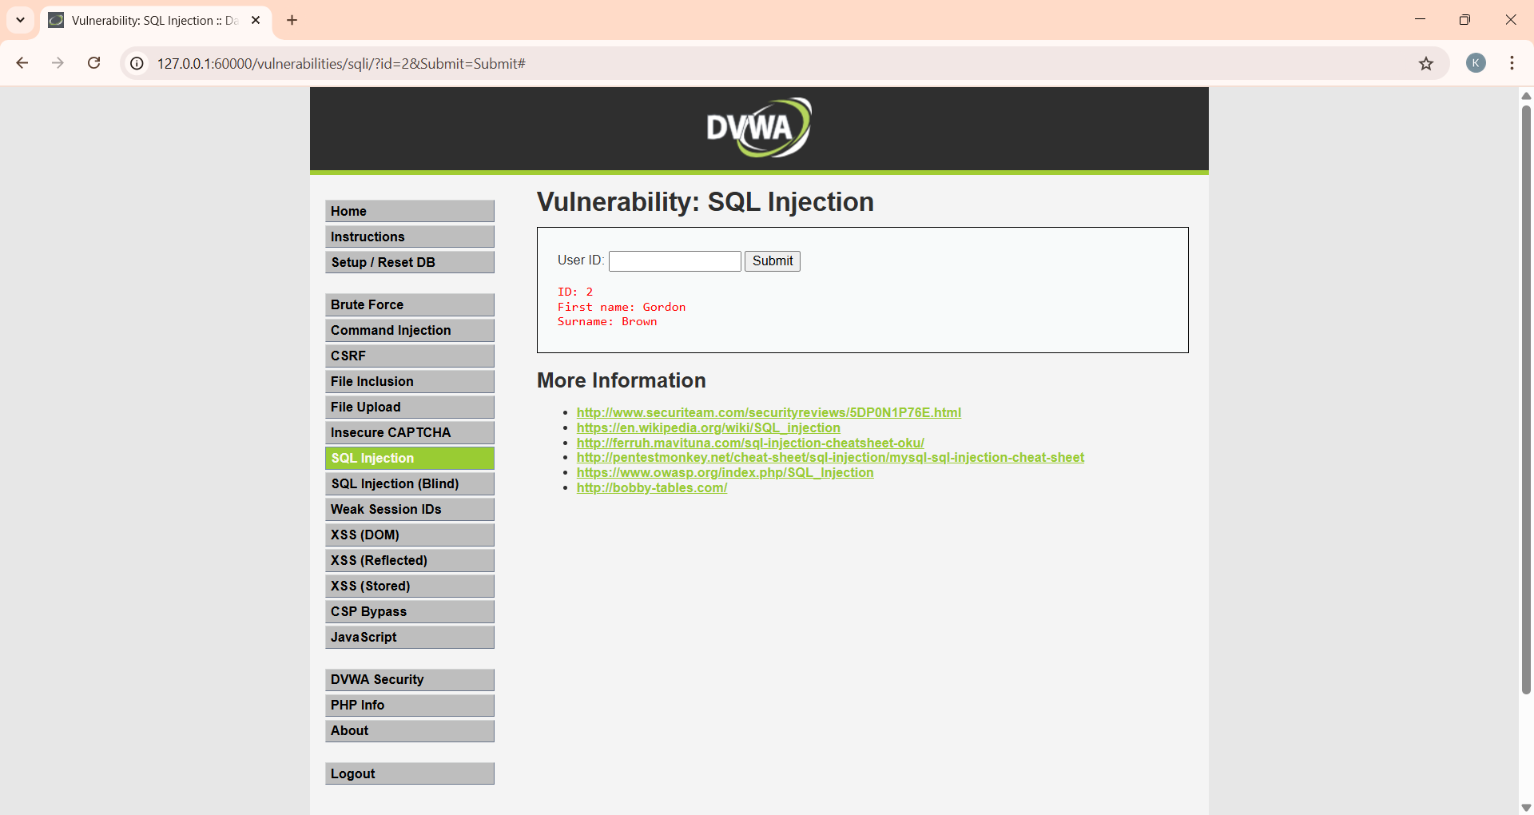

**b. Command Injection**

📷 *Input/Output* 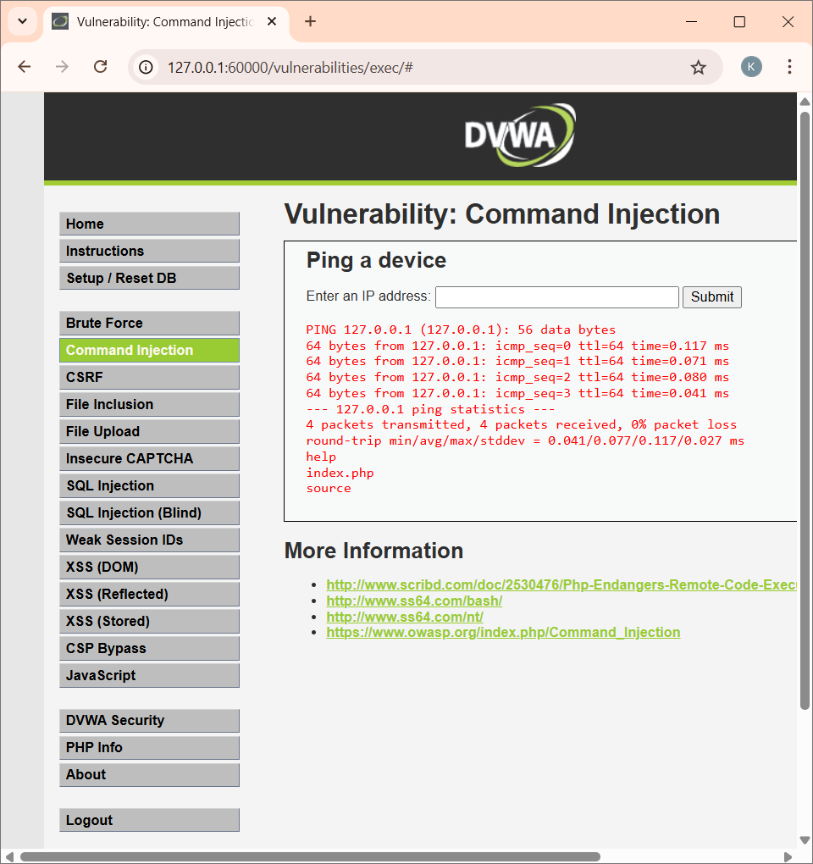

**c. XSS (Cross Site Scripting)**

📷 *Input/Output* 